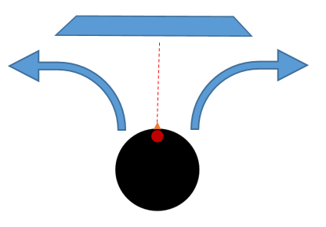
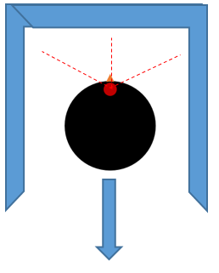
Case 2: Obstacle only in front
Case 1: Obstacle on all three sides
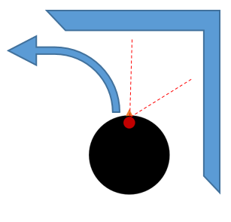
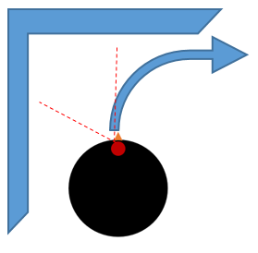
Case 4: Obstacle to the right and in front
Case 3: Obstacle to the left and in front

